|  |  |
| --- | --- |
| **To:** | Roya Solhmirzaei |
| **From:** | Team 4 - Caleb Howell, Essam Aljahmi, Yue Wang, and Kelsee Horrom |
| **Subject:** | Project 1 Checkpoint 2 |
| **Date:** | May 25, 2017 |

**Introduction:** The initial goal was to build a robot from the EV3 Lego Kit that could follow a black line using a light sensor. The next step was to make the robot capable of lifting and carrying a ball elevated and continue to follow the line with the ball elevated.

**Results:**The average speed of the previous design was tested and timed multiple times over a straight line measured at 32 inches. After the multiple trials, the average speed of the robot was calculated to be 2.53 inches per second by taking the 32 inch distance and dividing it by each trial and then taking the average. The current robot speed was not able to be tested since it had no more power left for us to track the results.

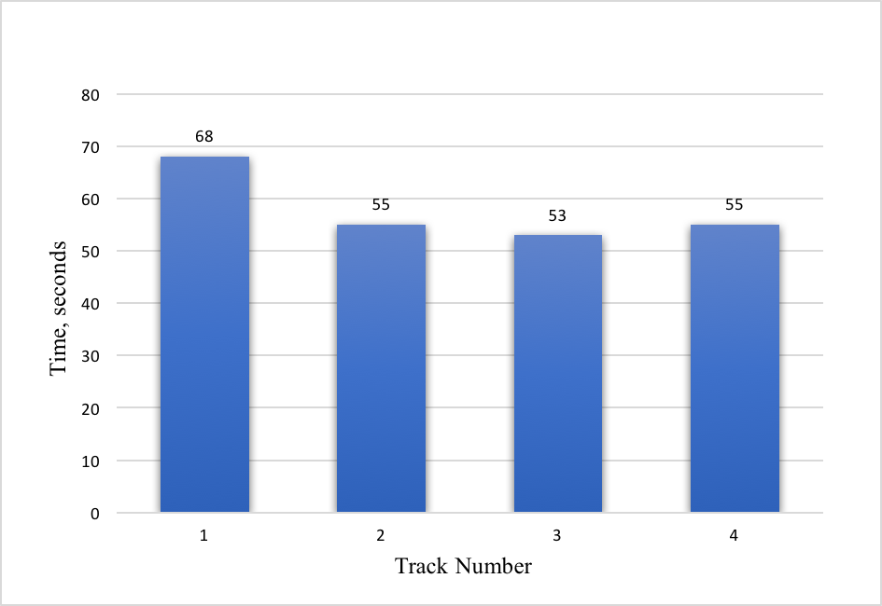

Figure 1: Previous Robot Time in Seconds

**Discussion:** The first problem the team ran into was the design of the robot from Checkpoint 1, the design could not lift a ball properly. Next, the team had difficulty creating a new design. After that there was Simulink parameters problems to make the new robot design function properly. Another important problem is the battery pack given does not work even when fully charged, it does not turn on the robot when secured in. Additional problems arose when people took the tracks that were in room 1312 so there could not be data collected for the robot until they were returned.

It took the team a while to figure out the robot from Checkpoint 1 was not suitable for Checkpoint 2. Some ideas were to ram the ball that was on a stand to make it fall into the arm basket before lifting it up. Other ideas include stabbing the stand with the ball in it and making the robot pick it up which seemed simple at the time but the stand design got in the way of the sensor. The main issue of the other robot was finding a way to get the ball picked up by the robot. The team constructed many apparatuses to hold the ball and developed numerous stands, but every time there was the problem of picking up the ball. From those ideas, the team learned that the new robot design should focus on picking up the ball.

After many failed design attempts and track runs, the team scrapped the first idea. While being stumped to find a new design the team found an inspirational video for the claws on YouTube [1]. Afterwards, things started to look up with both the robot, the Simulink program, and with the return of the track, there was a way to test the robot.

The new design of the robot has a claw mechanism that closes around the ball then lifts it up when the elbows of the arms hit the ground. Also had to move the ultrasonic sensor on top of the robot instead of keeping it on the bottom. An advantage of the new robot is that the robot can now pick up a ball while following the black line like the robot in Checkpoint 1. A disadvantage of the new robot was constructing the robot which was more complex than the other robot so it took more time. Additionally the robot was incapable of moving after the robot grabbed and picked up the ball since it was dragging the arms on the ground.

An advantage of the new Simulink program is having the robot do multiple tasks including following the black line, sensing the ball, stopping to pick up the ball, then continue on the path of the black line. Disadvantages of the new program is that it is more complex meaning it has multiple systems working with each other. If one parameter is not right it will throw off the whole program [2] which will make the robot not pick up the ball instead just run it over.

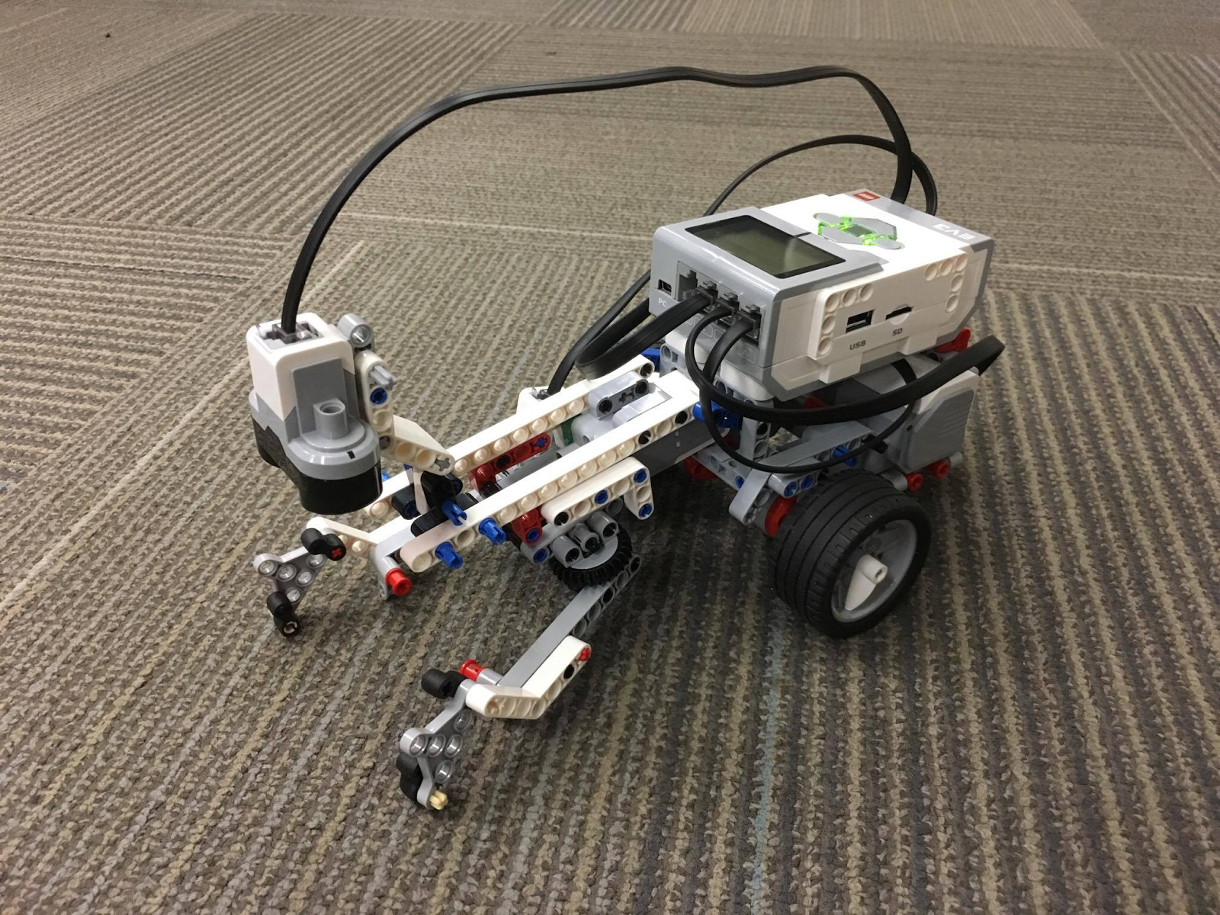

Figure 2: The New Robot Design

Reliability of the new robot is almost none because it seems like luck if the angle is right and the ball is placed in the right spot. The new robot speed is slower compared to robot 1 which is shown in Figure 1. With the ball the robot speed is around the same as without the ball. Weight of crane and batteries dying also affected the robot. However, the day it was tested before the deadline, the robot was capable of lifting the ball and traveling down the line. The team is not sure what changed between then and now, but there are videos as evidence of its success.

**References:**

1. “Building Grab and Lift Mindstorms EV3.” *YouTube,* uploaded by ogaworks, 28 November, 2016, <https://www.youtube.com/watch?v=nTLB9GWRyuo>
2. Solhmirzaei, Roya. “2017 Summer Semester Lab 2A.” Intro to Engineering Design 100, EGR 100, 24 May 2017, Engineering Building Room 1312, East Lansing, MI. Lab Lecture PowerPoint.